ChillnFree

Software Development Plan

Version <0.2>

Revision History

| **Date** | **Version** | **Description** | **Author** |
| --- | --- | --- | --- |
| 20/10/2021 | 0.1 | * Initial project plan | Võ Hoàng Bảo Duy  Trần Ngọc Lam  Lê Minh Sĩ  Đặng Kiệt Hào  Lê Quốc Trọng |
| 17/11/2021 | 0.2 | * Add the project estimates * Add the risk of management | Đặng Kiệt Hào  Lê Quốc Trọng |
|  |  |  |  |
|  |  |  |  |

Table of Contents

**Introduction** **4**

**Project Overview** **4**

*Project Purpose, Scope, and Objectives* *4*

*Assumptions and Constraints* *4*

*Project Deliverables* *4*

**Project Organization** **4**

*Organizational Structure* *4*

*Roles and Responsibilities* *5*

**Management Process** **5**

*Project Estimates* *5*

*Project Plan* *5*

Phase and Iteration Plan 5

Releases 6

Project Schedule 6

*Project Monitoring and Control* *7*

Reporting 7

Risk Management 7

Configuration Management 7

Software Development Plan

# 

# Introduction

This document contain:

* + Project overview: This section contains the project’s purpose and objectives, assumptions and constraints, project deliverables.
  + Project organization: This section contains the organizational structure and the detail of roles and responsibilities.
  + Management process: This section displays estimated cost and schedule of the project, the project plan, project monitoring and control.

# Project Overview

## Project Purpose, Scope, and Objectives

This Software Development Plan describes the overall plan to develop a website that makes it easy for people especially students and workers to listen to music with features a Pomodoro timer and some focus music for working and studying.

## Assumptions and Constraints

* Project has a fixed schedule of 12 weeks.
* Zero - budget.
* One web-server.
* Project has 5 people, there will be no more people added during the project.

## Project Deliverables

Deliverables for each project phase are identified in the Development Case. Deliverables are delivered towards the end of the iteration, as specified in section 4.2.3 Project Schedule.

# Project Organization

## Organizational Structure

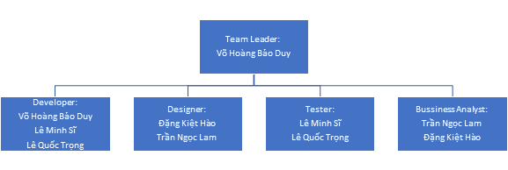

## Roles and Responsibilities

| **Role** | **Description** |
| --- | --- |
| Team leader | Assign task and check process |
| Designer | Design UI and Database |
| Developer | Coding |
| Business Analyst | Observe and evaluate the customer psychology |
| Tester | Test the features and check error |

# Management Process

## Project Estimates

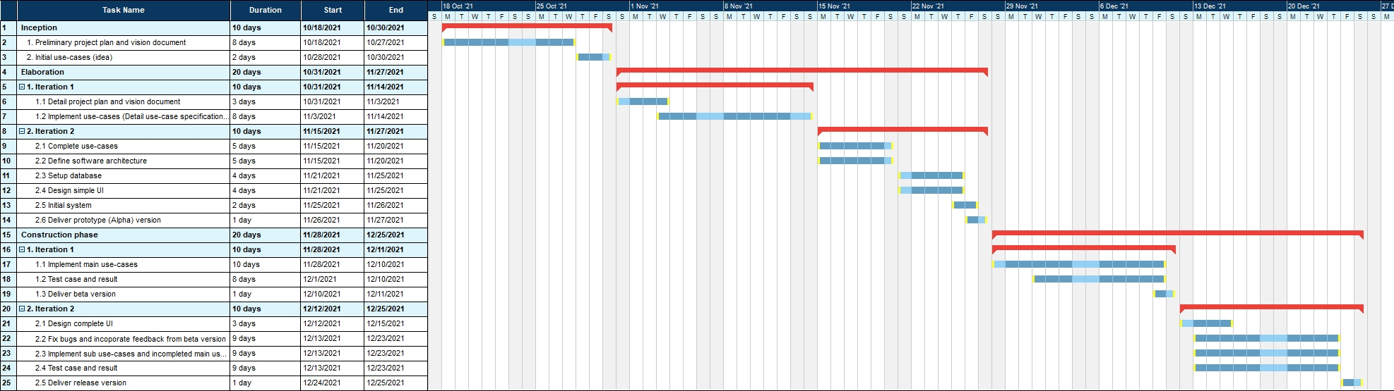

## Project Plan

### Phase and Iteration Plan

| **Phase** | **No. Of Iterations** | **Start** | **End** |
| --- | --- | --- | --- |
| Inception Phase | 1 | 18/10/2021 | 30/10/2021 |
| Elaboration Phase | 2 | 31/10/2021 | 27/11/2021 |
| Construction Phase | 2 | 28/11/2021 | 25/12/2021 |

| **Description** | **Milestone** |
| --- | --- |
| Inception Phase | The Inception Phase will analyze and research the environment that the software needed to execute through articles and resources online. After that will decide what function is able to do and what not and plan the process of building the software. |
| Elaboration Phase | The Elaboration Phase will develop the architectural prototype of the software. This version (prototype) will design and analyze all of the main use cases such as listening to the music, sign up, log in.... Also test cases for making sure to release a stable alpha version. This version will be the foundation for the next phase. |
| Construction Phase | The Construction Phase will develop all the functions that the software requires based on the foundation that the Elaboration Phase releases. After developing all the functions, the beta version will be released for testing. There will be testing and bug-fixing for the most at the end of the Construction Phase. |

| **Phase** | **Iteration** | **Objectives** |
| --- | --- | --- |
| Inception | Preliminary Iteration | Define product requirements, project plan and vision document |
| Elaboration | Setup and Initial System | -Detail documents  -Complete analysis and design for all use case  -Setup database and web server  -Design basic web UI |
| Develop Alpha (Prototype) | -Combine and develop the prototype (Alpha) version |
| Construction | Develop Beta | - Implement and test all main use cases.  - Develop the Beta Version |
| Bug-fixing / Develop Release | - Implement and test sub use cases.  - Fix bugs, optimize and incorporate feedback from Beta Version  - Develop the Release Version |

### Releases

Preliminary Iteration: Preliminary document of project plan and vision document.

Setup and Initial System: Detailed document of project plan, vision document and use-case specification. Also, release some basic web UI and ready for database and web server.

Develop Alpha (Prototype): Alpha version which is the first release that contains some of the basic functions and simple database. This release will be the foundation for the rest of the project.

Develop Beta: Beta version which is the release that contains most or all of the functions that were planned. This release will be for testing and bug-fixing.

Bug-fixing / Develop Release: Release version, this will be the final product of this project.

### Project Schedule

| **Phase** | **Iteration** | **Start-date** | **End-date** |
| --- | --- | --- | --- |
| Inception | Preliminary Iteration | 18/10/2021 | 30/10/2021 |
| Elaboration | Setup and Initial System | 31/10/2021 | 14/11/2021 |
| Develop Alpha (Prototype) | 15/11/2021 | 27/11/2021 |
| Construction | Develop Beta | 28/11/2021 | 11/12/2021 |
| Bug-fixing / Develop Release | 12/12/2021 | 25/12/2021 |
| Finalizing documents - Preparing for presentation | | 26/12/2021 | 03/01/2022 |

## Project Monitoring and Control

### Reporting

* Weekly meeting by Zoom application.
* Weekly status report by Google docs.
* Informal chats: Facebook, Slack.

### Risk Management

| **Risk ID** | **Risk Description** | **Risk type** | **Probability** | **Impact** | **Priority** | **Mitigation Strategy or Contingency Plan** |
| --- | --- | --- | --- | --- | --- | --- |
| 01 | Requirements changes in process | Type 1 | Unlikely | Insignificant | High | Derive traceability information to assess requirements change impact, maximise information hiding in the design. |
| 02 | Database performance slower than expected | Type 2 | Seldom | Moderate | Medium | Investigate the possibility of buying a higher performance database. |
| 03 | Staff illness | Type 1 | Occasional | Moderate | Medium | Split the ill staff’s work for every other member of the team. |
| 04 | Underestimate development time | Type 1 | Seldom | Serious | High | Investigate to improve the work efficiency of our team. |
| 05 | Server having a problem | Type 2 | Seldom | Catastrophic | High | Make sure every component system is available to other team members as a backup server. |
| 06 | Lack of communication between members | Type 1 | Occasional | Serious | High | Hold meetings regularly for members to exchange information and difficulty in work to other members. |
| 07 | Experienced staff leaving | Type 3 | Unlikely | Catastrophic | Medium | Split the leaving staff’s work for every other member of the team. If other members can’t solve the problem, that part of the project may be cancelled. |

### Configuration Management

Tools are used:

* Google drive for storing and sharing documents and files.
* Github for managing source code and related files.
* Slack for discussion and meeting.
* Trello for managing tasks.